**Read & Write Data from Excel File in Selenium Webdriver: POI & JXL**

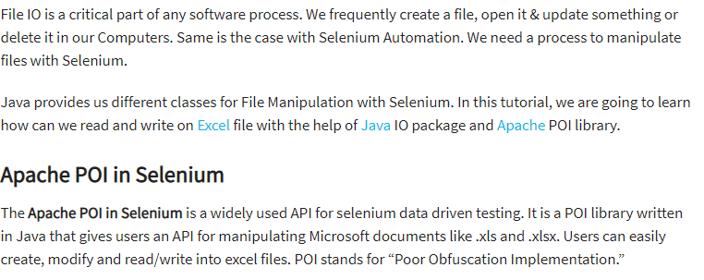

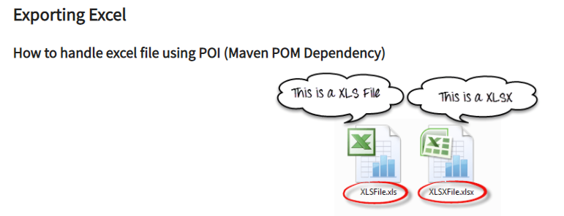

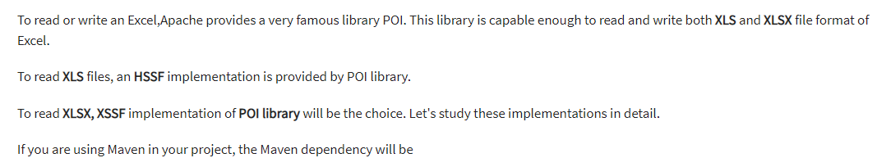

<dependency>

<groupId>org.apache.poi</groupId>

<artifactId>poi</artifactId>

<version>4.1.1</version>

</dependency>

